Imagining childhoods

Melissa Dennison

Simon Duncan

*With Freddie Poulsen*

**Acknowledgements**

With thanks to our creative writing tutor Amanda Lomas, and to our good friend Geoff Mills, whose help has been invaluable in helping us create many of the poems and stories in this pamphlet.

**The Girl with Red Hair**

And she dared paint her nails red

Our new teacher, from Belfast, they said.

Neighbours overheard

‘She must be a loose woman’.

Play fighting across the rows of desks

Rulers for swords

She caned your open hand

At least you were noticed

Out in the playground

Everyone running, shouting, shrieking.

Except you

Hugging safety by the school wall.

At last Sadie, the girl with red hair

Took hold of you

To play tig.

Her father shot an IRA man last night.

*Simon Duncan April 2024*

**Suburban Safari**

We are adventurers in a lost world,

Rachel, Richard and I, next door neighbours

jungle trekking through the bush,

our imaginations are engines throbbing,

ticking over with wild imaginings -

lions, tigers, and dragons may be hiding,

crouching

waiting

to leap out -

pouncing!

tearing us limb from limb -

swallowing us whole.

Near the stepping stones are monsters

toy dinosaurs lay scattered –

strewn across the path carefully constructed by Daddy.

We are creeping,

peeping

six circular eyes like flying saucers

heart beats thudding in our brains,

trepidation coursing through our veins,

hiding in suburban shrubbery

where jagged slivers of cerulean

pierce the spartan canopy,

blood red buds above our heads are waiting -

around our ankles, green tinged swords.

Time is an alien notion,

have we been exploring for minutes, hours or days?

reaching the jungles’ edge

stepping out onto the lawn,

shoes soaked by the shower kissed grass

relief

we made it!

*Melissa Dennison October 2023*

**Poets on a Platform**

**Melissa and Simon** are amateur poets who live in and around Saltaire, a world heritage site in Shipley, near Bradford. They call themselves *Poets on a Platform.*

**Emotion and reality**

*Platform* has several meanings. This pamphlet takes up the notion of platform as presentation. We use some of our poems and stories about childhoods, garnished with photos. Usually these depend on ideas and memories about our own childhoods. This begs the question of what is real and what is imagined. Can there be an emotional reality expressed through imaginary events? Is there a factual historical accuracy divorced from emotion?

The two opening poems are textbook examples of the fluid amalgam of emotion and reality. Both *The Girl with red hair,* and *Suburban safari* collate several memories into one narrative. But despite our attempts to remain true to distant childhood experiences, an affectionate nostalgia seeps down the years.

These questions become particularly telling in poems and stories about childhood. We depend upon fragmentary and idealised memories, on what other people tell us, and what we think is expected. At an extreme we have no conscious memories about early infancy, still less about being born. Our poems ‘I am born’ overleaf must therefore depend on what others have told us, on pervasive family narratives, on what we imagine might have been, and on historical accounts of those far off years.

**I am born**

Outside, a long total eclipse

Arabs and Israelis lock horns,

peace accords in France are fixed, a

new era for Vietnam

Inside, bright light, sterility

'Don't you want to push?' asks the nurse,

confused by her reality -

the chaos of my mum's first birth

Outside, a city is throbbing,

it's Saturday night, disco time -

bodies shimmering and dancing,

to the beat, a rhythm sublime

Inside, I am still, something's wrong,

Dad is told to leave the room now,

this labour has gone on too long -

ripped out by forceps, shocked, I howl.

*Melissa Dennison September 2023*

**I am born.**

The Peoples’ Republic of China is proclaimed.

Book at Bedtime begins on the BBC.

Chocolate and sweets are no longer rationed

and I am born.

I am told I had extraordinary long arms

Or so it seemed to my father,

shocked, holding his counsel

He thought I was deformed.

Late August, back end, promises unfulfilled.

Taking in the harvest

One grandma will name me Spencer

Luckily switched to a second name.

I lie on my dad’s flying jacket, rescued from the war.

Fear and hope impregnate the thick, woolly lining.

He came out of it alive,

so do I.

*Simon Duncan October 2023*

**Haiku**

by Melissa Dennison 2024

Haiku strip away narrative and explanation to more powerfully use succinct imagery to express the emotion of experience.

another year

older

the light plays in the trees

trees…

watching

me

g

r

o

w

splash!

her first summer

playing in puddles

closer

to my second childhood

than my first

**Prose and Atmosphere**

Haiku often convey the emotion of the present moment, but prose may have greater opportunity for imparting atmosphere. Melissa and Simon use prose stories to return to the early child experiences introduced in the opening poems.

Locked in

My parents had this crazy idea that it would be good for me to go to pre-school, to get me ready for school. The nearest playgroup was about five minutes from where we lived, in a 1960’s low prefabricated building - an extension to the local methodist church. I have few memories from this time, and what I have aren’t great. My is falling onto the side of an old iron bathtub that passed for a sand pit in the playground. My mouth and nose burst open like a ripe watermelon, and blood ran down my face. Somewhere in my parent’s things is a box of photos with one of me with a face swelled up like a football. This left a legacy, wonky teeth that no orthodontist has ever been able to fix.

The second memory occurred after story time one day. It was home time, and a long line of three- and four-year-olds were filing out of a little room right at the back of the old Victorian church building. As usual I was at the back of the line. Just as I got to the door, the childminder turned off the light and shut the door. Maybe she hadn’t seen me, I don’t know. I grabbed the handle, but it wouldn’t budge. I tried again. I was locked in. I banged on the door,

‘Let me out’, I wailed,

‘LET ME OUT,’ I cried, banging on the door with my fists.

No response.

The room was pitch black. Scared of the dark, fear and panic swept over me like a tsunami. From the corner of my eye, I could see a shape moving, emerging out of the stygian gloom.

Tears were coursing down my face.

‘Mummy’ I yelled, stretching up on my tip toes I reached out for the door handle again. Grabbing it I tried as hard as I could to turn it. The handle would not budge. My hands were just too small.

‘MUMMEEEEEE,’ I cried.

‘LET ME OUT’

‘MUMMMEEEEEE,’

I was feeling exhausted, my breathing heavy. The shape was getting nearer, bearing down on me. It was a monster. A monster that was coming to get me. My heart began to beat frantically, leaping about in my chest. I sobbed hysterically, snot intermingling with my tears.

I hammered hard on the door, kicking and screaming.

Then the door handle began to move. Someone was opening it. Yellow light poured in. It was Mummy! She had found me. Bending down she scooped me up in her arms. Relief washed over me like an avalanche. Safe at last, my face hidden in her lapel. The monster vanished. I never went back to playgroup.

Melissa Dennison December 2023

Mullaghmore Park Road

My parents are English. I know that. But I’m not English, I’m Irish, Northern Irish that is. Which to be clear means protestant.

I am even the leader of the Mullaghmore Park street gang. Proudly trotting on my pretend horse in front of the others. That’s our playground, from Arthur Lyons’ corner shop, on Station Road. Past the hidden awfulness of the Jowett’s bungalow. Past my house - which my parents called ‘Bedford’. Then past Stewart Dickson’s house before petering out by the Merrick’s in chicken runs and blackberry hedges.

We never see the Jowett boy, he never comes out. And anyway, we are forbidden to go near him. He has TB. He did come out once. We ran away.

It's a. rough, stony playground. We often fall, riding bikes, pretend fighting. That means a scrubbing. A harsh brush, Dettol and some orange stuff that stings. It hurts, the flesh is red and raw. But it’s good for you. The grit comes out, the germs are killed, your knees are scarred.

I’m really good at throwing stones. But even with my stone throwing we daren’t stray down past the station. That’s where the tough boys moved out from the Shankill are.

Our schoolteacher has come from Belfast too, it is said. She dares to paint her nails red.

Opposite Bedford a field has survived. The farmer, it is said, is Catholic. Strange. Come hay time he makes haystacks. I went to England once. The silly farmers there put their hay in square plastic bags. What a waste of time

Besides, those haystacks are wonderful to slide down. Hay spreads over the filed. Hay is scratchy, your clothes ride up, disturbed insects sting and bite. Red welts, spots and pimples. They might become infected, as I busily scratch arms and back. Out comes the scrubbing brush again. Infection is kept out. My skin smarts.

One day we wander over the top road, through the golf course, and up the Knockagh Hill. Steep woods, loose rocks, crumbling cliffs. We drag ourselves up, grabbing branches, digging in with hands and feet. Getting down is easy, a long mud slide to the golf course. Pity about my new shorts. I will be in trouble when I get home. *Simon Duncan October 2023*

**Playtime!**

At times as adults we still remember what it felt like to be children and sometimes that playfulness and mischief inspires our writing.

There’s a polar bear in the fridge!

Open the fridge

and look inside

a polar bear is hiding behind

a bottle of milk and cheesy quiche

'How did you get there?' asks a small boy,

surprised

'I took a wrong turning at a bend

in Lapland,

my sat nav went awry' the polar bear

replied,

'Yum! this margarine

tastes like a dream!'

the polar bear said, sticking his paw into the tub

'Is there any more of this fine

grub?'

'May I come out?'

'I promise to be good!'…

'I won't eat you'

Clambering out he spills

milk all over the floor

the little boy closes the door

trying to hide the flood, and says

'Better not tell mummy.'

Melissa Dennison 2024

**Ballad for a banded snail**

With my home on my back

I love the freedom of the road

it may look heavy

but it's a light load

No mortgage or loans

no worry or groans

up and down many a leaf

and stem I go

I love to forage in your annual beds

nibbling

munching

and crunching my way through your veg

I am the bane of the green fingered

who kindly leave out bowls of beer

for me to drink and hopefully sink

down into a never-ending sleep

I like to think

that I can fool you,

I am clever

only coming out at night

My only trace is a trail of shimmering

slime

and the scene of crime -

evidence of half-eaten flowers....

Melissa Dennison 2023

Simon’s 10-year-old grandson, **Freddie**, joined in composing haiku and amusing poems during family walks in the Lake District. Descending the last hill on one of these walks, Freddie spotted yellow fungus growing from a tree. His capture of this with an arresting image initiated poetic composition with Simon over the next few days. Both grandson and grandad enjoyed the turn to schoolboy humour.

**Paradise lost**

Hanging fungus yellow popcorn

Bright green mattresses of moss

Rowan berries like orange stars

In the bracken tawny dawn.

But nature’s paradise gets lost,

You have been warned,

For amongst that ferny universe

Ticks await in swarms.

Deer, sheep or human. To them it’s the same

They sense animal motion, heat and din.

Thick warm blood, that’s their aim

As they drop from frond to skin.

Don’t wear shorts,

Don’t leave the path,

Get the tick remover ready

And drown them in the bath.

You start to itch all over

Every black spot sparks alarm.

Friends search behind your knees

Nature has lost its charm.

Someone mutters ‘Lyme’s disease’

Alarm turns to panic.

Family inspect your inner thighs

They say you’re needlessly dramatic

But even your love ones are embarrassed

They retreat behind red lines

They will not examine folds and crevices

In places where the sun never shines

So bend over double mirrors

Twist and turn, it’s a yoga farce

Just remember reverse vision,

As you tweezer round your ……..posterior?

*Simon Duncan and Freddie Poulsen August 2023*

Returning home to school and family life Freddie began to write his own poetry from the different perspective of a ten-year-old. Without memories, without nostalgia. He uses an acrostic poem to make a direct comment about the day at school, composed on the walk home. He finds rhyming couplets in mocking his older sister.

Six

Cruel

Hours

Of

Odious

Lessons

**Teenager in training - my sister**

I get told off because I scoff, chocolate, sweets

biscuits and treats

When will my life begin!

When will I grow up!

I don’t want to chat

because it’s always speaking crap.

I am a teenager and everything is boring

everything is dull and nothing is adoring.

I don’t want to mention

but I’m always in detention

I hate my mum,

she’s really dumb.

When will my life *begin?*

*Freddie Poulsen, autumn 2023*

**Images from childhood**

As childhood is a social construct it is also continuously changing and evolving. The photos below show how our experiences of childhood have changed and will continue to do so as society changes. One obvious change is that the digital world is increasingly important as a space for childhood exploration, perhaps in the way that the old bomb sites, wild woods and hills and moors were for previous generations.

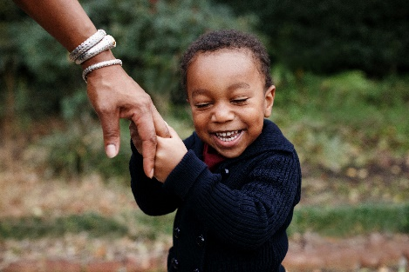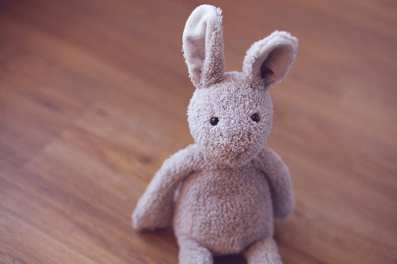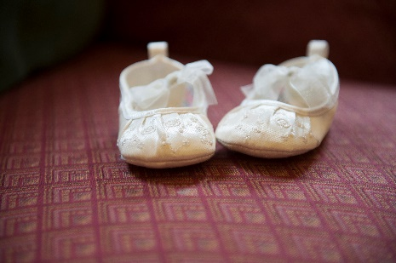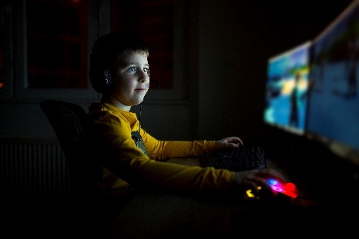

**Childhood as a social relation**

Childhood is not a biological given state. Rather it is a concept that is created by us. For most of the historical past, physically dependent infancy quickly led to immature adulthood. But by the Victorian era the demand for workers and citizens promoted a longer period of training and learning. This soon became impregnated with the creation of social distinction. There have many permutations in this social construction. The ‘intensive parenting’ of the 90s is a notable example - parents anxiously micromanaged their children’s development and activity.

This underlines a basic feature of childhood. It is a social relation. For childhood to exist, you need parenthood. Our last few poems reflect this relationship and introduce anxieties about time and generation.

**Younger daughter**

My younger daughter is like a deep, dark well

You never know what she feels.

Her baby face hides a stern resolve

To only tell you what she thinks you need.

Her pierced nose gives a clue

She has her agenda and it’s not you.

Her hair is like a chameleon’s skin

Brown, red, or strawberry blond

Snapchat, Instagram and Love Island.

But despite this shield I like to think

That my little girl still lives in that dark deep.

*Simon Duncan October 2023*

**Aberffraw**

Falling off the beachside rock  
I clutched a tussock of sea whitened grass.

Magically, I ascended in a graceful parabola.

Reaching the apex, my dad was far below.

‘That’s a long way to fall’ I thought.

But the grass let me down gently  
Onto the glistening white sand.  
‘See’ I said to my father, ‘it's alright’.  
‘Well done’ he replied, despite being dead for almost 20 years.  
He wasn't a ghost, just a normal dad walking along the beach with his son.

We reached the cliffs, white limestone, plunging vertically into the sea

Sharp and clean. `Some fine climbs there.’  
More ancient cliffs stood and crumbled on a raised beach, just before.

Underneath, nettles, sea cabbage and thistle.

Our red and green ball lodged at the bottom.

‘Careful’ said my dad, ‘All that loose rock just waiting for this moment to arrive’.

Gingerly, I retrieved the ball, hugging it to my chest.  
Suddenly I was the dad  
As my son, Oscar, retrieved the ball.  
‘Well done’ I said.  
We walked back to our holiday cottage by the sea.

Waking gently from this parallel universe  
My memory caressed the image of Ty Glan y Mor,  
Well-loved by these sons and fathers  
The cottage by the sea, near Aberffraw.  
And somewhere underneath remains of the palace

Where the Princes of Wales held court.  
Totally extinguished by the conquering English, in 1301.

*Simon Duncan June 2024*

**Christingle**

Hair brushed to a glossy sheen

navy uniforms smell of fresh ironing

one hundred hands cradle the world

flickers from the candles

shadows on Victorian stones

slowly wax drips.

Our voices rise to this occasion

rehearsed over and over in

the hall, which I enjoy

as dreaded maths is cancelled.

Outside the world is

plunged into blackness

wrapping around me like

as dreaded maths is cancelled.

Outside the world is

plunged into blackness

wrapping around me like

a close friend, this time

of year is magical,

yet I don't stop or think

about the pretty

red ribbon

winding round.

Or that in three months’ time

we will be celebrating death,

why does love demand this sacrifice?

Melissa Dennison January ’24